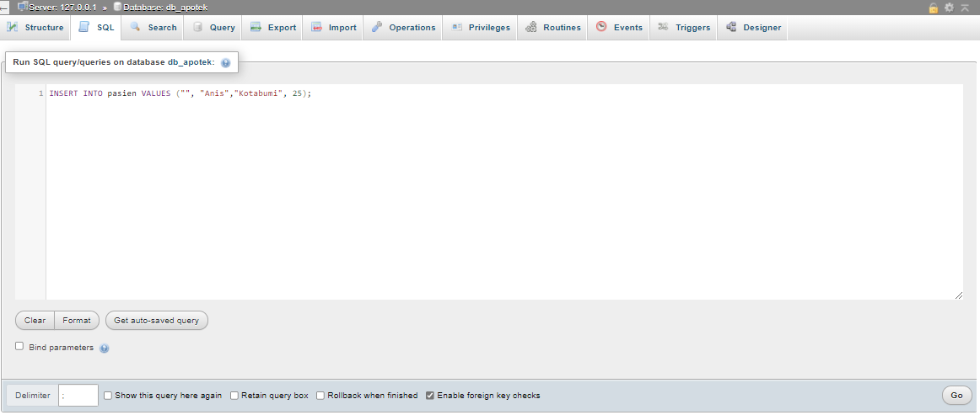Before Run SQL

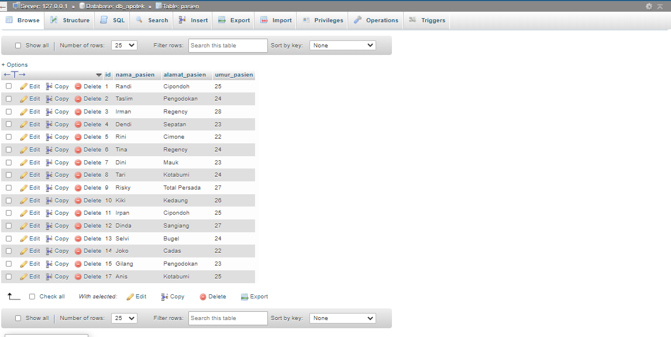

After Run SQL

1. INSERT

* INSERT INTO pasien VALUES ("", "Anis","Kotabumi", 25);

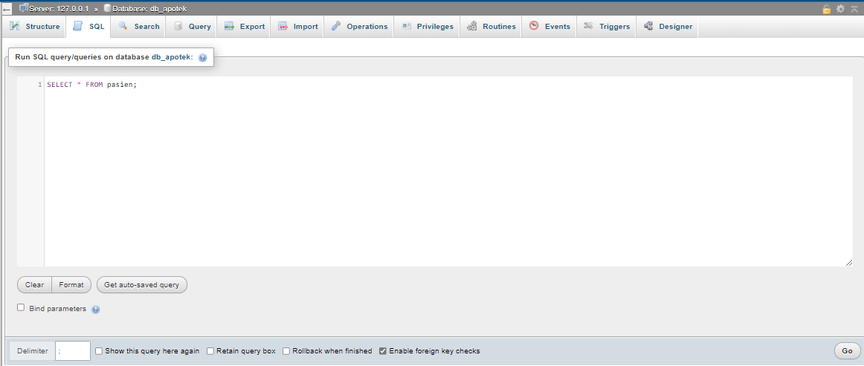Before Run SQL

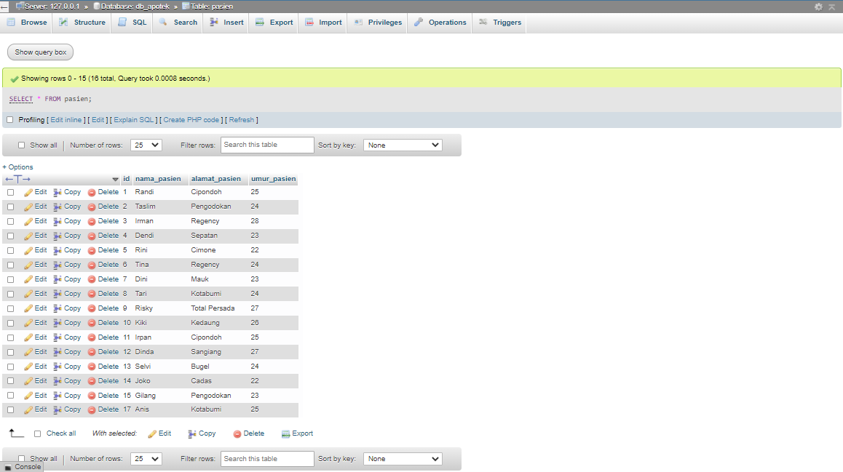

After Run SQL

1. SELECT

* SELECT * FROM pasien;

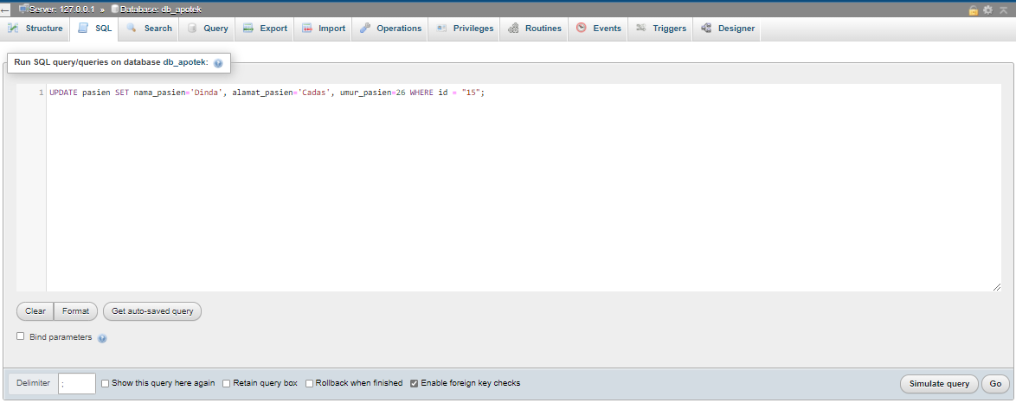Before Run SQL

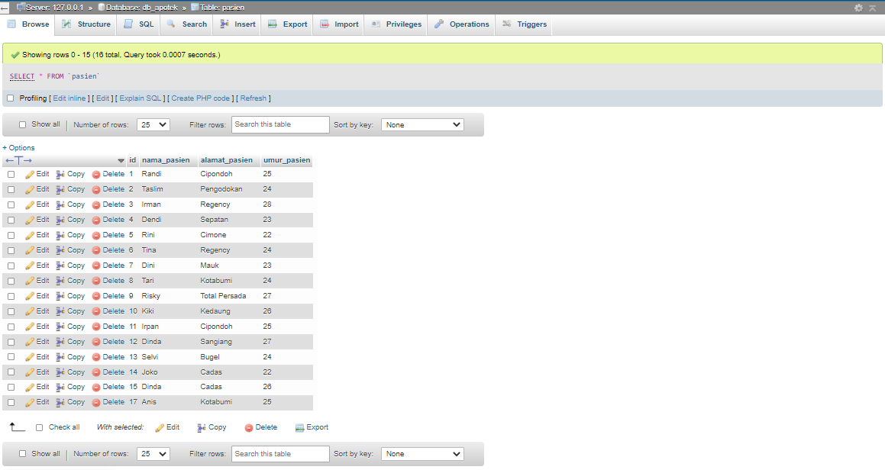

After Run SQL

(Sebelum Run nama_pasien : Gilang, alamat_pasien : Pengodokan, umur_pasien : 28)

1. UPDATE

* UPDATE pasien SET nama_pasien='Dinda', alamat_pasien='Cadas', umur_pasien=26 WHERE id = "15";

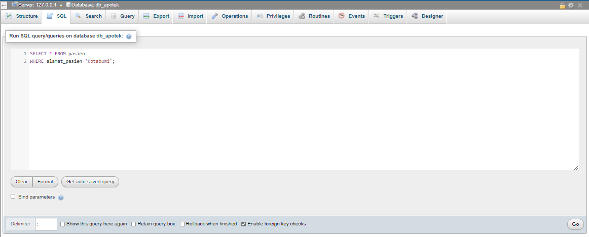

Before Run SQL

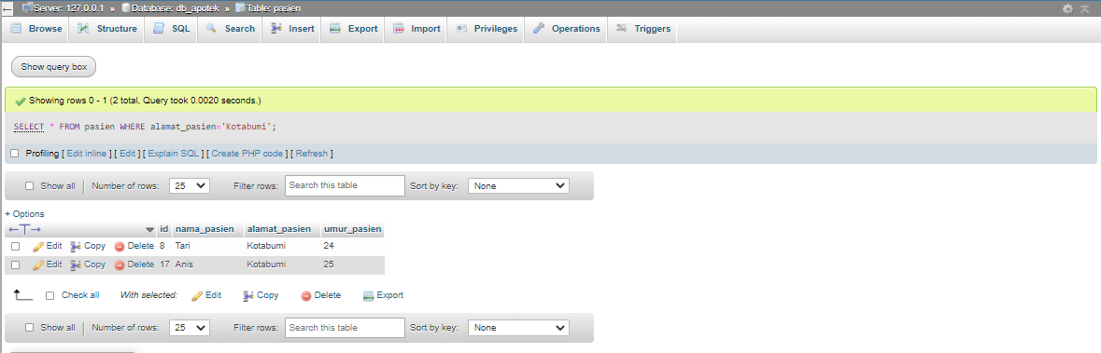

After Run SQL

1. WHERE

* SELECT * FROM pasien WHERE alamat_pasien='Kotabumi';

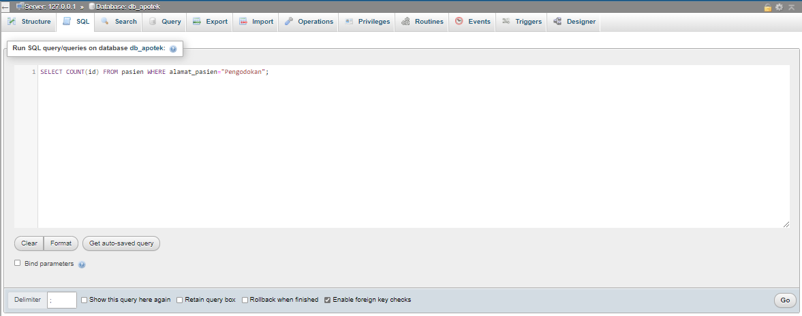

Before Run SQL

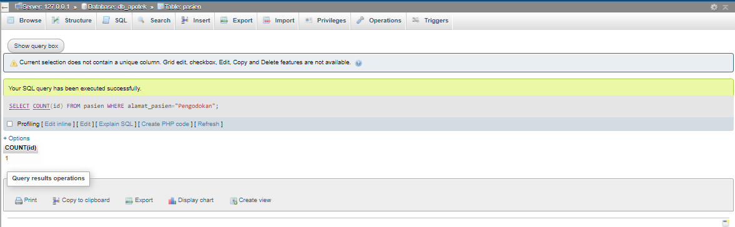

After Run SQL

1. COUNT

* SELECT COUNT(id) FROM pasien WHERE alamat_pasien="Pengodokan";

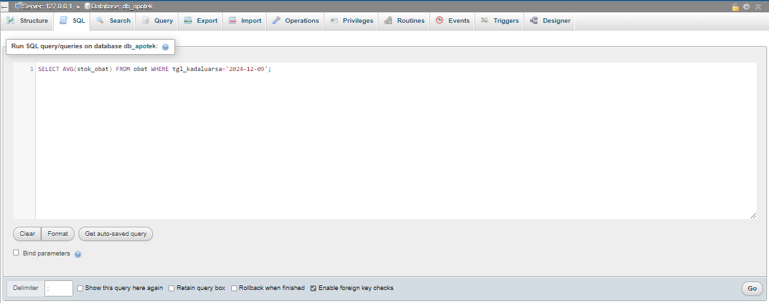

Before Run SQL

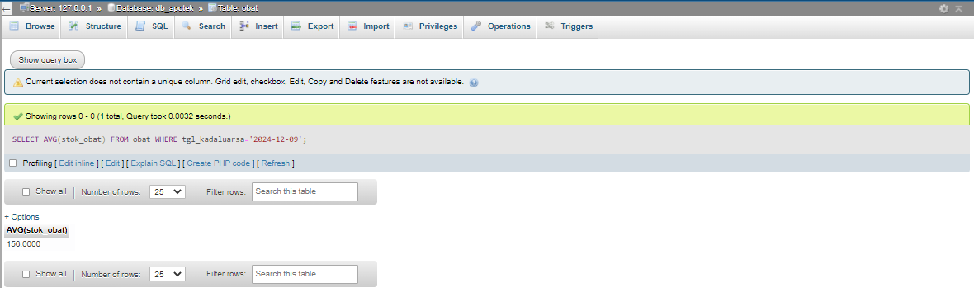

After Run SQL

1. AVG

* SELECT AVG(stok_obat) FROM obat WHERE tgl_kadaluarsa='2024-12-09';

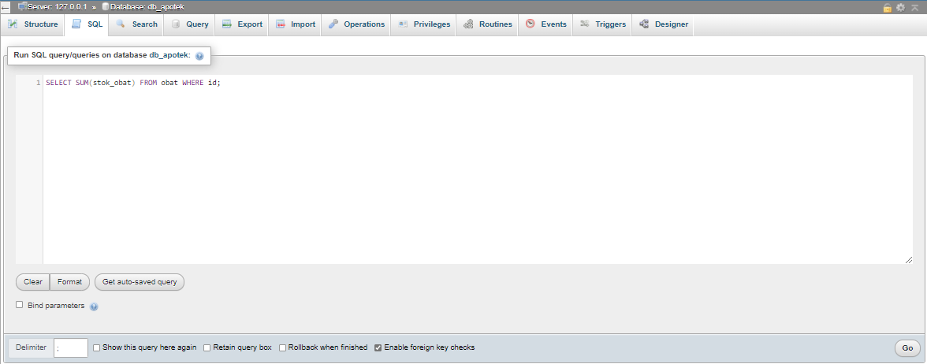

Before Run SQL

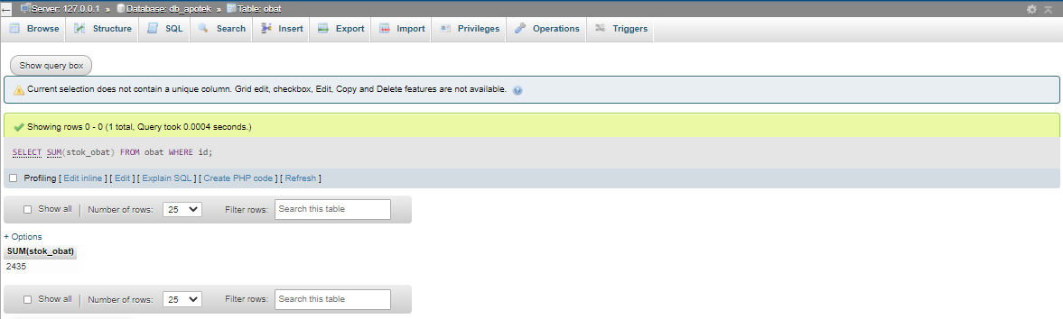

After Run SQL

1. SUM

* SELECT SUM(stok_obat) FROM obat WHERE id;

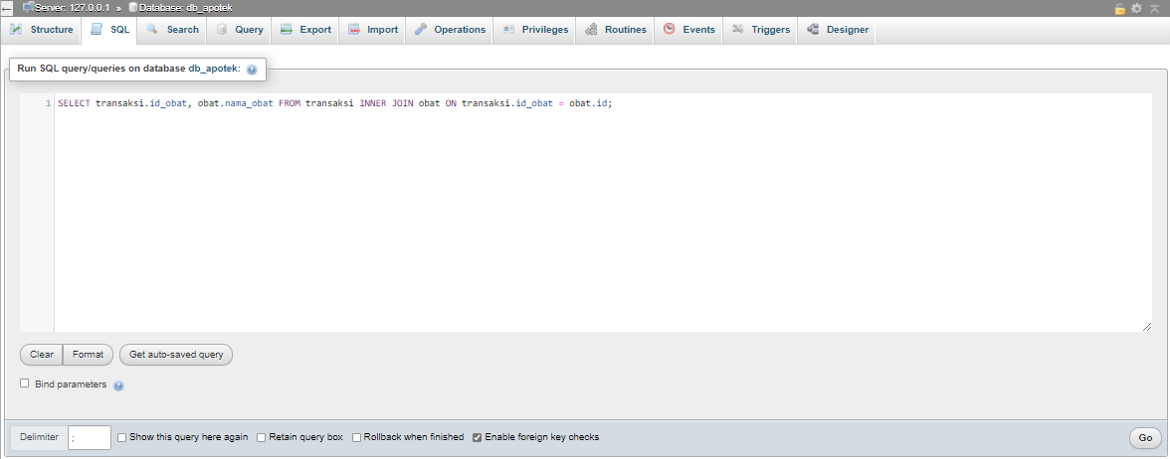

Before Run SQL

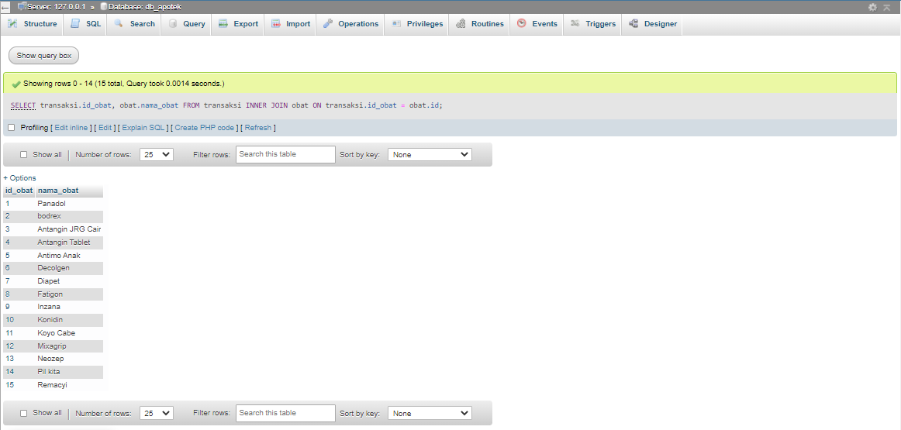

After Run SQL

1. INNER JOIN

* SELECT transaksi.id_obat, obat.nama_obat FROM transaksi INNER JOIN obat ON transaksi.id_obat = obat.id;

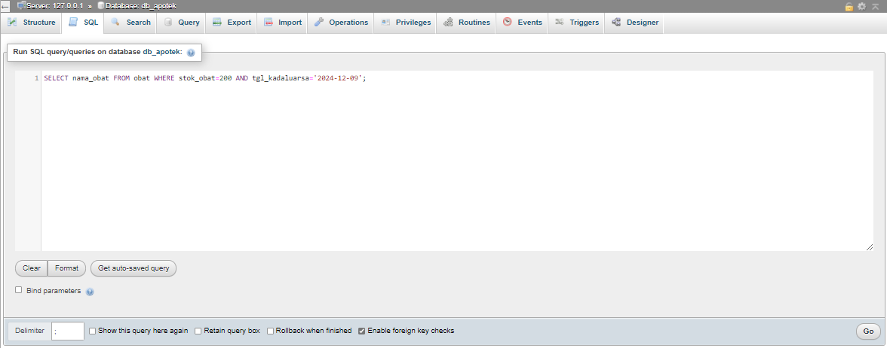

Before Run SQL

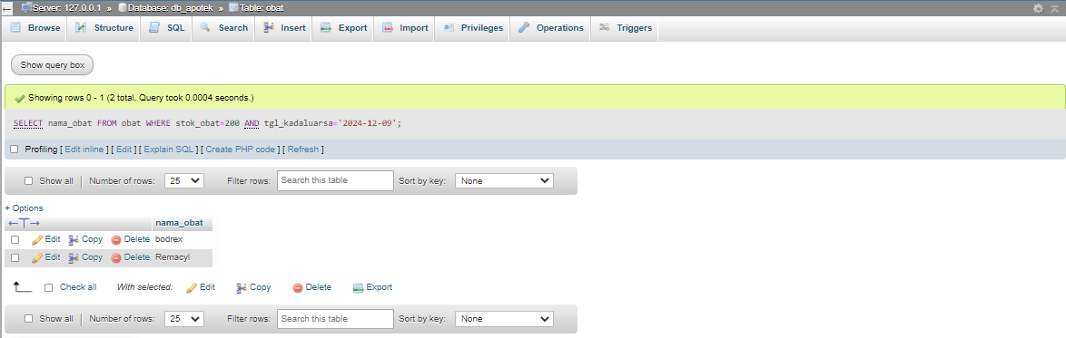

After Run SQL

1. AND

* SELECT nama_obat FROM obat WHERE stok_obat=200 AND tgl_kadaluarsa='2024-12-09';

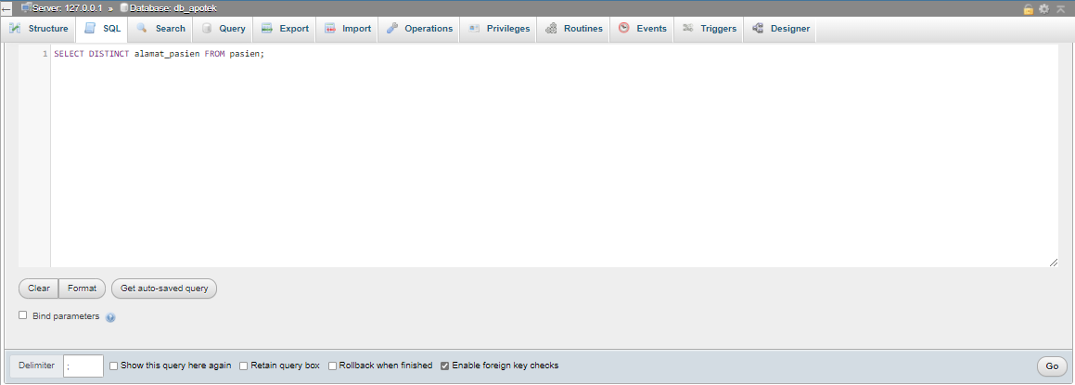

Before Run SQL

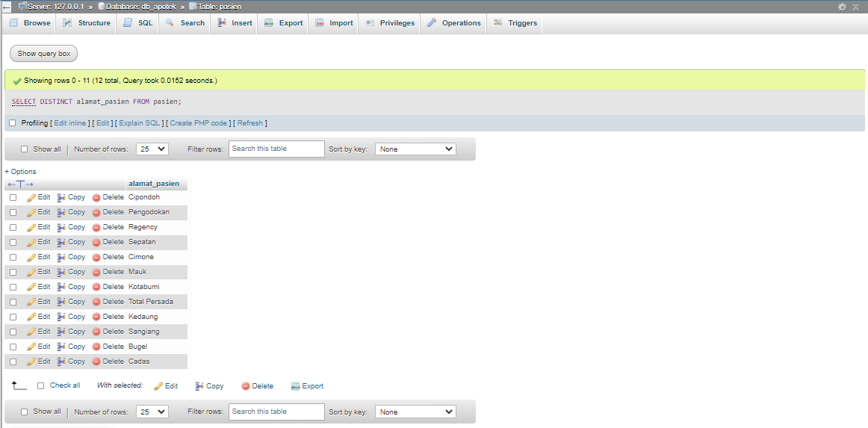

After Run SQL

1. DISTINCT

* SELECT DISTINCT alamat_pasien FROM pasien;